RL.6.1 Cite evidence from the text to support your claims from information either stated in the text or learned by drawing inferences.
PBG Title
Date
Score

RL.6.2 Determine a theme or central idea of a text and locate the details that support that theme. Provide a summary of the text (leaving out your opinion).
PBG Title
Date
Score

RL.6.3 Describe the plot of a particular story. As the story moves toward a resolution, describe how the characters respond or change.
PBG Title
Date
Score

RL.6.4 Determine the meaning of words and phrases as they are used in a text, including figurative and connotative meanings; and how they impact the tone.
PBG Title
Date
Score

RL.6.5 Analyze how theme, setting, and plot are developed because of a particular sentence, chapter, or scene.
PBG Title
Date
Score

Reading Standards - Literature

Reading Standards - Literature

RL.6.6 Explain how an author develops the point of view of the narrator or speaker in a text.
PBG Title
Date
Score

RL.6.7 Compare and contrast the experience of reading a story, drama, or poem to listening to or viewing an audio, video, or live version of the text. Contrast what you “see” and “hear”.
PBG Title
Date
Score

RL.6.9 Compare and contrast texts in different genres and how they approach the same theme or topic.
PBG Title
Date
Score

RL.6.10 By the end of the year, read and comprehend literature, including stories, dramas, and poems, on grade level or above (up to 8th grade reading level).
PBG Title
Date
Score

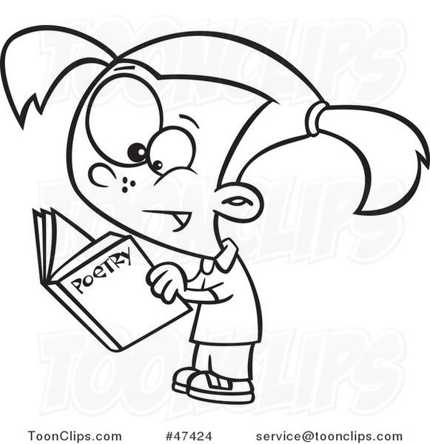

Reading Standards - Informational

RI.6.1 Cite evidence from the text to support your claims from information either stated in the text or learned by drawing inferences.
PBG Title
Date
Score

RI.6.2 Determine a theme or central idea of a text and locate the details that support that theme. Provide a summary of the text (leaving out your opinion).
PBG Title
Date
Score

RI.6.3 Analyze in detail how a key individual, event, or idea is introduced, illustrated, and elaborated in a text.
PBG Title
Date
Score

RI.6.4 Determine the meaning of words and phrases as they are used in a text, including figurative, connotative, and technical meanings.
PBG Title
Date
Score
.
RI.6.5 Analyze how a particular sentence, paragraph, chapter, or section contributes to your understanding of the information.
PBG Title
Date
Score

Reading Standards - Informational

RI.6.6 Explain how an author develops the point of view of the narrator or speaker in a text.
PBG Title
Date
Score

RI.6.7 Analyze information from multiple sources (different media or formats) to develop an understanding of a topic or issue.
PBG Title
Date
Score

RI.6.8 Evaluate the argument and specific claims in a text. Distinguish between claims that are supported by evidence and claims that are NOT.
PBG Title
Date
Score

RI.6.9 Compare and contrast an author’s presentation of events with that of another (e.g., a memoir written by and a biography on the same person).
PBG Title
Date
Score

R.I.6.10 By the end of the year, read and comprehend nonfiction on grade level or above (up to 8th grade reading level).
PBG Title
Date
Score

Writing Standards

6W1 Write arguments that support your claims with relevant evidence (prove it!).
PBG Title
Date
Score

6W2 Write informative/explanatory texts that show what you have learned about a topic. Use relevant and reliable sources to convey ideas and concepts.
PBG Title
Date
Score

6W3 Write narratives to tell a story. Use descriptive details and a well-structured sequence of events.
PBG Title
Date
Score

6W4 Produce clear and easy to understand writing in which the development, organization, and style are appropriate for the topic and/or the people for whom it is being written.
PBG Title
Date
Score

6W5 Develop and strengthen writing as needed by planning, revising, editing, rewriting, or trying a new approach. Have peers, teachers, or other adults edit your work and offer suggestions to improve your writing.
PBG Title
Date
Score

6W6 Use technology to produce and publish writing. Type a minimum of 3 pages in one sitting.
PBG Title
Date
Score

6W7 Conduct short research projects to answer a question using several sources.
PBG Title
Date
Score

Writing Standards

6W8 Gather relevant information from multiple print and digital sources. Decide if the information is correct and useful. Quote or paraphrase the information while avoiding copying the information word for word (plagiarism).
PBG Title
Date
Score

6W9 Take evidence from different texts to support your analysis and/or research of a topic.
PBG Title
Date
Score
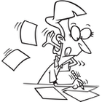
SL stands for “Speaking and Listening”
SL.1 Engage effectively in a range of collaborative discussions.
PBG Title
Date
Score

SL2 Explain how information contributes to a topic, text, or issue being studied.
PBG Title
Date
Score

SL4 Present claims and findings. Make eye contact and speak clearly and loudly.
PBG Title
Date
Score

SL5 Include graphics, images, music, etc. to visual displays to clarify information.
PBG Title
Date
Score

Language Standards

6.L1 Use the correct English grammar when writing and speaking.
PBG Title
Date
Score

6.L2 Spell correctly, use capital letters correctly, and punctuate sentences correctly.
PBG Title
Date
Score

6.L3 Use your knowledge of all other language conventions when writing, speaking, reading, or listening.
PBG Title
Date
Score

6.L4 Learn the definition of unknown or multiple-meaning words and phrases in several different ways (for example, context clues, vocabulary lessons, dictionaries).
PBG Title
Date
Score

6.L5 Demonstrate an understanding of figurative language (i.e. similes, personification, etc.), word relationships, and shades of meaning.
PBG Title
Date
Score

6.L6 Learn and use grade-appropriate general academic and domain-specific words (for example, words that are only used when writing about space) and phrases. As you learn new vocabulary words, consider whether or not those words could be used in your writing to “show what you know” or express yourself better.
PBG Title
Date
Score

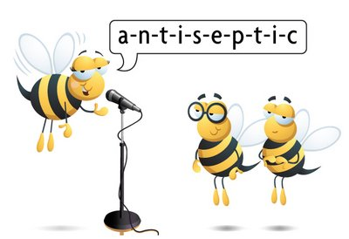

NS stands for “Number Sense”. Number sense means an understanding of numbers and their relationships.
5.NF.1 Add and subtract fractions
PBG Title
Date
Score

5.Nf.4 Multiply fractions
PBG Title
Date
Score

6.NS.1 Divide fractions
PBG Title
Date
Score

6.NS.2 Multiply multi-digit numbers using traditional strategies.
PBG Title
Date
Score

6.NS.2 Divide multi-digit numbers using traditional strategies.
PBG Title
Date
Score

6.NS.3 Add, subtract, multiply, and divide multi-digit decimals using traditional strategies.
PBG Title
Date
Score

6.NS.4 Find the least common multiple of two whole numbers.
PBG Title
Date
Score

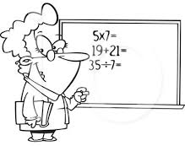

Math Standards

6.NS.4 Find the prime factors of a whole number.
PBG Title
Date
Score

6.NS.4 Find the greatest common factor of two whole numbers. Use several strategies including the distributive property.
PBG Title
Date
Score

6.NS.5 Understand that positive and negative numbers represent opposite values of numbers.
PBG Title
Date
Score

6.NS.6 Understand a rational number as a point on the number line. Use that understanding to find rational numbers on both a horizontal and vertical number line as well as points on a coordinate plane. (**This standard requires a student be able to convert decimals to fractions and fractions to decimals)
PBG Title
G
Date
Score

6.NS.7 Understand the absolute value of rational numbers.
PBG Title
Date
Score

6.NS.8 Solve real-world and mathematical problems by graphing points in all four quadrants of the coordinate plane. Find distances between points with the same x-coordinate or the same y-coordinate.
PBG Title
Date
Score

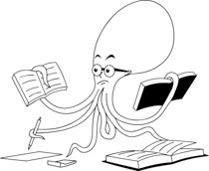

Math Standards

RP stands for “Ratios and Proportions”. Ratios are used to compare values between numbers and proportions tell you whether or not ratios are equivalent.
6.RP.1 Understand the concept of a ratio and use ratio language to describe a ratio relationship between two quantities.
PBG Title
Date
Score

6.RP.2 Understand that unit rate means to find the value of 1. Recognize that unit rate is found by dividing and is signaled by the word “per”.
PBG Title
Date
Score

6.RP.3 Use ratio and rate reasoning to solve real-world and mathematical problems, using strategies such as tables of equivalent ratios, tape diagrams, double number line diagrams, or equations involving unit rate problems. Build on this skill by finding the percent of a quantity.
PBG Title
Date
Score

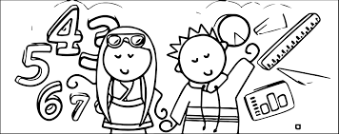
EE stands for “Expressions and Equations”. Expressions are numbers and symbols (2 x 3) and equations show that two things are equal (2 x 3 = 1 x 6)
6.EE.1 Write and evaluate (solve) numerical expressions involving whole-number exponents.
PBG Title
Date
Score

6.EE.2 Write, read, and evaluate expressions in which letters (variables) stand for numbers.
PBG Title
Date
Score

6.EE.3 Solve expressions following the “Order of Operations” (PEMDAS).
PBG Title
Date
Score

Math Standards

Math Standards

6.EE.4 Identify when two expressions are equivalent (=).
PBG Title
Date
Score

6.EE.5 Solve equations or inequalities (< >) by answering the question “which numbers make an equation or inequality true?” Substitute different numbers as you try to answer that questions or create a list of possible solutions.
PBG Title
Date
Score

6.EE.6 Use variables to represent numbers and write expressions using variables when solving a real-world or mathematical problem.
PBG Title
Date
Score

6.EE.7 Solve real-world and mathematical problems by writing and solving equations of the form x + a = b and ax = b. Use inverse operations to get the variable (x) by itself.
PBG Title
Date
Score

6.EE.8 Write an inequality (x > c or x < c) to represent a condition in a real-world or mathematical problem. Recognize that inequalities have an infinite number of solutions that can be represented by graphing them on a number line.
PBG Title
Date
Score

6.EE.9 Understand the difference between an independent and dependent variable and how the independent variable “controls” the dependent variable. Create charts or input/output tables to show your understanding. Use those tables to graph the equation.
PBG Title
Date
Score

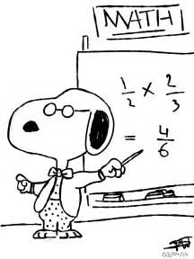

G stands for “Geometry”. Geometry is math that deals with points, lines, shapes and space.
6.G.1 Find the area of rectangles, parallelograms, and trapezoids (quadrilaterals) as well as right triangles.
PBJ Title
Date
Score

6.G.1 Use your ability to find the area of the above shapes to decompose other polygons (for example, a pentagon) by breaking them into either triangles or trapezoids. Use this same skill to find the area of composite shapes.
PBJ Title
Date
Score

6.G.2 Find the volume of a rectangular prism using the formula b x l x h. The prism can have sides measured in whole numbers or fractions.
PBJ Title
Date
Score

6.G.3 Draw polygons on a coordinate plane when given coordinates for the vertices (corners). Use coordinates to determine the length of each side of the polygon or to complete a shape.
PBJ Title
Date
Score

6.G.4 Represent three-dimensional figures using nets made up of rectangles and triangles, and use the nets to find the surface area of these figures.
PBJ Title
Date
Score

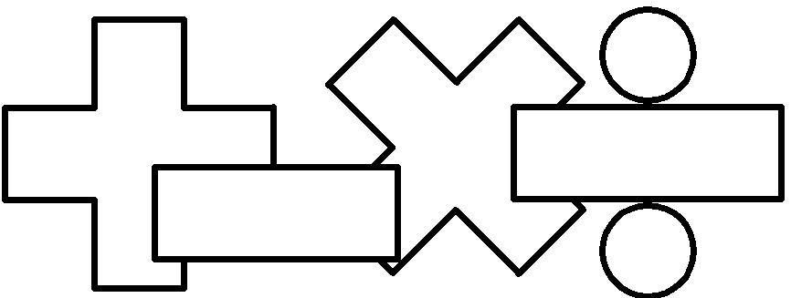
SP stands for “Statistics and Probability”. Statistics are pieces of data that give you information and probability is the likelihood of something happening.

6.SP.1 Recognize a statistical question as one that will generate different pieces of data as people respond to a question (for example, “How many siblings do you have?”).
PBJ Title
Date
Score

Math Standards

6.SP.2 Analyze a set of data collected to find it’s center, range, and overall shape.
PBG Title
Date
Score

6.SP.3 Recognize that MEAN is a measure of center for a numerical data set that summarizes all of the data into a single number.
PBG Title
Date
Score

6.SP.3 Recognize that MEDIAN is a measure of center for a numerical data set that summarizes all of the data into a single number.
PBG Title
Date
Score

6.SP.3 Recognize that MODE is a measure of center for a numerical data set that summarizes all of the data into a single number.
PBG Title
Date
Score

6.SP.4 Display numerical data in dot plots, histograms, and box plots. Choose the most appropriate graph/plot for the data collected.
PBG Title
Date
Score

6.SP.5 Summarize data sets by reporting the number of observations, describing the attribute, including how it was measured. Look for any outliers that may change the validity of the information. Express your findings by either solving for the Mean Absolute Deviation or using a box plot.
PBG Title
Date
Score

Math Standards

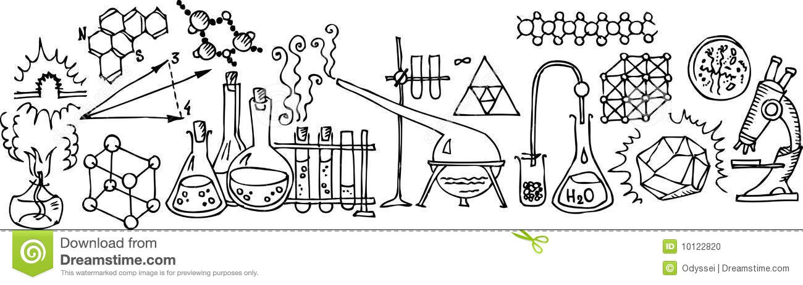

Science Standards

6. 1 . 1 Develop and use a model of the Sun-Earth-Moon system to describe the cyclic patterns of the lunar (moon) phases, eclipse of the Sun and Moon, and seasons.
PBG Title
Date
Score

6. 1 . 2 Develop and use a model to describe how gravity keeps objects in our solar system in orbital motion.
PBG Title
Date
Score

6. 1 . 3 Determine the scale and properties of objects in the solar system. Examples of scale could include size and distance. Examples of properties could include layers, temperature, surface features and orbital range.
PBG Title
Date
Score

6.2.1 Develop models to show that molecules are made of different kinds, proportions and quantities of atoms. Understand that there are differences between atoms and molecules, and that certain combinations of atoms form specific molecules.
PBG Title
Date
Score

6.2.2 Develop a model to predict the effect of heat energy on states of matter (solid, liquid, or gas) and density. Include the arrangement of particles in each state of matter as well as during phase changes (melting, freezing, condensing, and evaporating)
PBG Title
Date
Score

6.2.3 Plan and carry out an investigation to determine the relationship between temperature, (the amount of heat transferred) and the change in motion of particles. Investigate all 3 states of matter (solid, liquid, or gas).
PBG Title
Date
Score

6.2.4 Design an object, tool or process that minimizes or maximizes heat energy transfer. Make a prototype (original model) of the above, run tests, analyze the data, and determine whether changes need to be made to your prototype.
PBG Title
Date
Score

Science Standards

6.3.1 Develop a model to describe how the cycling of water through Earth’s systems is driven by energy from the Sun and gravitational forces.
PBG Title
Date
Score

6.3.2 Collect and analyze weather data to explain how air flows from regions of high pressure to low pressure that result in a change in the weather.
PBG Title
Date
Score

6.3.3 Develop and make a model of the sun to show how unequal heating of the Earth’s systems causes patterns of atmospheric and oceanic circulation that determine regional climates. Emphasize how warm water and air move from the equator towards the poles.
PBG Title
Date
Score

6.3.4 Construct an explanation for the role of the natural greenhouse effect in Earth’s energy balance, and how it enables life to exist on Earth. Examples could include comparisons between Earth and other planets such as Venus and Mars.
PBG Title
Date
Score

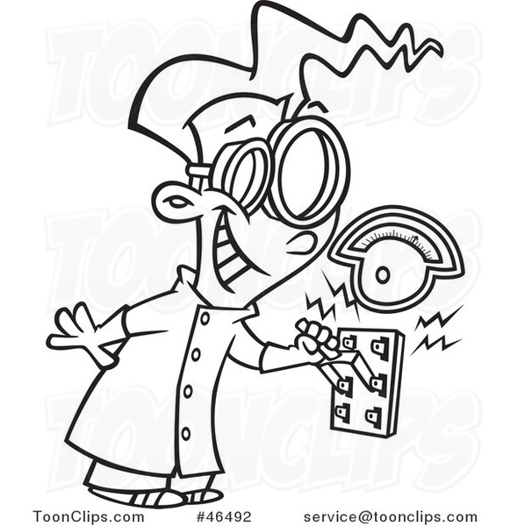
6.4.1 Analyze data to provide evidence that explains why resources available effects whether or not organisms can continue to live in certain ecosystems. Ask questions to predict how changes in resource availability affects organisms in those ecosystems. Examples could include water and food.
PBG Title
Date
Score

6.4.2 Construct an explanation that predicts how organisms from different ecosystems would interact. Interactions might introduce competition, predation (one organism hunting another), and mutualism (both organisms benefit).
PBG Title
Date
Score

6.4.3 Develop a model to describe food webs and the role of producers, consumers, and decomposers in various ecosystems. Examples could include Utah ecosystems.
PBG Title
Date
Score

6.4.4 Construct an argument supported by evidence that the stability of populations is affected by changes to an ecosystem. Emphasize how changes to living and nonliving components in an ecosystem affect populations in that ecosystem. Examples could include Utah.
PBG Title
Date
Score

6.4.5 Evaluate solutions for preserving ecosystem services that protect resources and biodiversity (different life forms) based on how well the solutions can keep an ecosystem stable.
PBJ Title
Date
Score

Science Standards

Standard 1: Students will understand how ancient civilizations developed and how they contributed to the current state of the world.
6. 1 . 1 Explain why physical geography affected the development of early civilizations.
PBG Title
Date
Score

6. 1 . 2 Evaluate how religion has played a central role in human history from ancient times to today.
PBG Title
Date
Score

6. 1 . 3 Explain how modern governments can trace some of their attributes to the systems of power, authority, and governance established in ancient civilizations.
PBG Title
Date
Score

6. 1 . 4 Analyze how the earliest civilizations created technologies and systems to meet community and personal needs.
PBG Title
Date
Score

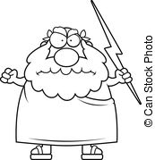

Social Studies

Social Studies

Standard 2: Middle Ages and the Renaissance and the impact of this transformation on modern times.

6.2.1 Explain how physical geography affects economic and cultural expansion.
PBG Title
Date
Score

6.2.2 Explore the impact of religion in the Middle Ages and the Renaissance and its relevance to modern times.
PBG Title
Date
Score

6.2.3 Examine how systems of governance began steps toward self-rule during the Middle Ages and the Renaissance.
PBG Title
Date
Score

6.2.4 Explain the importance of the Renaissance as a rebirth of cultural and intellectual pursuits.
PBG Title
Date
Score

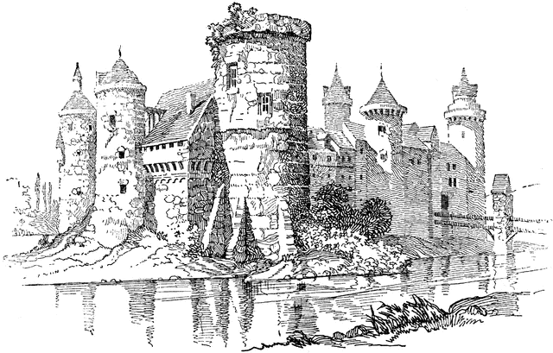

Social Studies

Standard 3: Students will understand how revolutions have had an impact on the modern world.
6.3.1 Understand the processes of revolution.
PBG Title
Date
Score

6.3.2 Analyze the impact of selected revolutions.
PBG Title
Date
Score

Standard 4: Students will understand current global issues and their rights and responsibilities in the interconnected world.
6.4.1 Analyze how major world events of the 20th century affect the world today.
PBG Title
Date
Score

6.4.2 Explore current global issues facing the modern world and identify potential solutions.
PBG Title
Date
Score
.
6.4.3 Determine human rights and responsibilities in the world.
PBG Title
Date
Score

Reading Standards
RL.6.1 – Cite textual evidence to support analysis of what the text says explicitly as well as inferences drawn from the text.
RL.6.2 – Determine a theme or central idea of a text and how it is conveyed through particular details; provide a summary of the text distinct from personal opinions or judgements.
RL.6.3 – Describe how a particular story’s or drama’s plot unfolds in a series of episodes, as well as how the characters respond or change as the plot moves toward a resolution.
RL.6.4 – Determine the meaning of words and phrases as they are used in a text, including figurative and connotative meanings; analyze the impact of a specific word choice or meaning and tone.
RL.6.5 – Analyze how a particular sentence, chapter, scene, or stanza fits into the overall structure of a text and contributes to the development of the theme, setting, or plot.
RL.6.6 – Explain how an author develops the point of view of the narrator or speaker in a text.
RL.6.7 – Compare and contrast the experience of reading a story, drama, or poem to listening to or viewing an audio, video, or live version of the text, including contrasting what they “see” and “hear” when reading the text to what they perceive when they listen or watch.
RL.6.9 – Compare and contrast texts in different forms or genres in terms of their approaches to similar themes and topics.
RL.6.10 – By the end of the year, read and comprehend literature, including stories, dramas, and poems, in the grades 6-8 text complexity band proficiently, with scaffolding as needed at high end of the range.
R1.6.1 – Cite textual evidence to support analysis of what the text says explicitly as well as inferences drawn from the text.
R1.6.2 – Determine a central idea of a text and how it is conveyed through particular details; provide a summary of the text distinct from personal opinions or judgments.
R1.6.3 – Analyze in detail how a key individual, event, or idea is introduced, illustrated, and elaborated in a text.
R1.6.4 – Determine the meaning of words and phrases as they are used in a text, including figurative, connotative, and technical meanings.
R1.6.5 – Analyze how a particular sentence, paragraph, chapter, or section fits into the overall structure of a text and contributes to the development of ideas.
R1.6.6 – Determine the author’s point of view or purpose in a text and explain how it is conveyed in the text.
R1.6.7 – Integrate information presented in different media or formats (e.g. visually, quantitatively) as well as in words to develop a coherent understanding of a topic or issue.
R1.6.8 – Trace and evaluate the argument and specific claims in a text, distinguishing claims that are supported by reasons and evidence from claims that are not.
R1.6.9 – Compare and contrast on author’s presentation of events with that of another (e.g., a memoir written by and a biography on the same person).
R1.6.10 – By the end of the year, read and comprehend literary nonfiction in the grades 6-8 text complexity band proficiently, with scaffolding as needed at the high end of the range.
Writing Standards
6W1 Write arguments that support your claims with relevant evidence (prove it!).
6W2 Write informative/explanatory texts that show what you have learned about a topic. Use relevant and reliable sources to convey ideas and concepts.
6W3 Write narratives to tell a story. Use descriptive details and a well-structured sequence of events.
6W4 Produce clear and easy to understand writing in which the development, organization, and style are appropriate for the topic and/or the people for whom it is being written.
6W5 Develop and strengthen writing as needed by planning, revising, editing, rewriting, or trying a new approach. Have peers, teachers, or other adults edit your work and offer suggestions to improve your writing.
6W6 Use technology to produce and publish writing. Type a minimum of 3 pages in one sitting.
6W7 Conduct short research projects to answer a question using several sources.
6W8 Gather relevant information from multiple print and digital sources. Decide if the information is correct and useful. Quote or paraphrase the information while avoiding copying the information word for word (plagiarism).
6W9 Take evidence from different texts to support your analysis and/or research of a topic.
Speaking and Listening Standards
SL.1 Engage effectively in a range of collaborative discussions.
SL2 Explain how information contributes to a topic, text, or issue being studied.
SL4 Present claims and findings. Make eye contact and speak clearly and loudly.
SL5 Include graphics, images, music, etc. to visual displays to clarify information.
Language Standards
6.L1 Use the correct English grammar when writing and speaking.
6.L2 Spell correctly, use capital letters correctly, and punctuate sentences correctly.
6.L3 Use your knowledge of all other language conventions when writing, speaking, reading, or listening.
6.L4 Learn the definition of unknown or multiple-meaning words and phrases in several different ways (for example, context clues, vocabulary lessons, dictionaries).
6.L5 Demonstrate an understanding of figurative language (i.e. similes, personification, etc.), word relationships, and shades of meaning.6.L6 Learn and use grade-appropriate general academic and domain-specific words (for example, words that are only used when writing about space) and phrases. As you learn new vocabulary words, consider whether or not those words could be used in your writing to “show what you know” or express yourself better.
Science Standards

6. 1 . 1 Develop and use a model of the Sun-Earth-Moon system to describe the cyclic patterns of the lunar phases, eclipse of the Sun and Moon, and seasons. Examples of models could be physical, graphical, or conceptual.
6. 1 .2 Develop and use a model to describe the role of gravity and inertia in orbital motions of objects in our solar system.
6. 1 .3 Use computational thinking to analyze data and determine the scale and properties of objects in the solar system. Examples of scale could include size and distance. Examples of properties could include layers, temperature, surface features and orbital range.
6.2.1 Develop models to show that molecules are made of different kinds, proportions and quantities of atoms. Emphasize understanding that there are differences between atoms and molecules, and that certain combinations of atoms form specific molecules.
6.2.2 Develop a model to predict the effect of heat energy on states of matter and density. Emphasize the arrangement of particles in states of matter (solid, liquid, or gas) and during phase changes (melting, freezing, condensing, and evaporating)
6.2.3 Plan and carry out an investigation to determine the relationship between temperature, the amount of heat transferred, and the change of average particle motion in various types or amounts of matter. Emphasize recording and evaluating data.
6.2.4 Design an object, tool or process that minimizes or maximizes heat energy transfer. Identify criteria and constraints, develop a prototype for interactive testing, analyze data from testing, and propose modifications for optimizing the design solution.
6.3.1 Develop a model to describe how the cycling of water through Earth’s systems is driven by energy from the Sun, gravitational forces, and energy.
6.3.2 Investigate the interactions between air masses that cause changes in weather conditions. Collect and analyze weather data to provide evidence for how air masses flow from regions of high pressure to low pressure causing a change in the weather.
6.3.3 Develop and make a model of the sun to show how unequal heating of the Earth’s systems causes patterns of atmospheric and oceanic circulation that determine regional climates. Emphasize how warm water and air move from the equator towards the poles.
6.3.4 Construct an explanation supported by evidence for the role of the natural greenhouse effect in Earth’s energy balance, and how it enables life to exist on Earth. Examples could include comparisons between Earth and other planets such as Venus and Mars.
6.4.1 Analyze data to provide evidence for the effects of resource availability on organisms and populations in an ecosystem. Ask questions to predict how changes in resource availability affects organisms in those ecosystems. Examples could include water and food.
6.4.2 Construct an explanation that predicts patterns of interactions among organisms across multiple ecosystems. Emphasize consistent interactions in different environments, such as competition, predation and mutualism.
6.4.3 Develop a model to describe the cycling of matter and flow of energy among living and nonliving parts of an ecosystem. Emphasize food webs and the role of producers, consumers, and decomposers in various ecosystems. Examples could include Utah ecosystems.
6.4.4 Construct an argument supported by evidence that the stability of populations is affected by changes to an ecosystem. Emphasize how changes to living and nonliving components in an ecosystem affect populations in that ecosystem. Examples could include Utah.
6.4.5 Evaluate competing design solutions for preserving ecosystem services that protect resources and biodiversity based on how well the solutions maintain stability within the ecosystem. Emphasize obtaining, evaluating, and communicating of information.

Social Studies Standards

6.1.1 Explain why physical geography affected the development of early civilizations.
6. 1 . 2 Evaluate how religion has played a central role in human history from ancient times to today.
6. 1 . 3 Explain how modern governments can trace some of their attributes to the systems of power, authority, and governance established in ancient civilizations.
6. 1 . 4 Analyze how the earliest civilizations created technologies and systems to meet community and personal needs.
6.2.1 Explain how physical geography affects economic and cultural expansion.
6.2.2 Explore the impact of religion in the Middle Ages and the Renaissance and its relevance to modern times.
6.2.3 Examine how systems of governance began steps toward self-rule during the Middle Ages and the Renaissance.
6.2.4 Explain the importance of the Renaissance as a rebirth of cultural and intellectual pursuits.
6.3.1 Understand the processes of revolution.
6.3.2 Analyze the impact of selected revolutions.
6.4.1 Analyze how major world events of the 20th century affect the world today.
6.4.2 Explore current global issues facing the modern world and identify potential solutions.
6.4.3 Determine human rights and responsibilities in the world.

Math Standards

6.RP.1 Understand the concept of a ratio and use ratio language to describe a ratio relationship between two quantities.
6.RP.2 Understand the concept of a unit rate a/b associated with a ratio a:b with b ≠ 0, and use rate language in the context of a ratio relationship
6.RP.3 Use ratio and rate reasoning to solve real-world (with a context) and mathematical (void of context) problems, using strategies such as reasoning about tables of equivalent ratios, tape diagrams, double number line diagrams, or equations involving unit rate problem. Solve for percent of quantity.
6.NS.1 Interpret and compute quotients of fractions.
6.NS.2 Fluently divide multi-digit numbers using the standard algorithm
6.NS.3 Fluently add, subtract, multiply, and divide multi-digit decimals using the standard algorithm for each operation.
6.NS.4 Find the greatest common factor of two whole numbers less than or equal to 100 and the least common multiple of two whole numbers less than or equal to 12. Use the distributive property to express a sum of two whole numbers 1–100 with a common factor as a multiple of a sum of two whole numbers with no common factor
6.NS.5 Understand that positive and negative numbers are used together to describe quantities having opposite directions or values
6.NS.6 Understand a rational number as a point on the number line. Extend number line diagrams and coordinate axes familiar from previous grades to represent points on the line and in the plane with negative number coordinates.
6.NS.7 Understand ordering and absolute value of rational numbers
6.NS.8 Solve real-world and mathematical problems by graphing points in all four quadrants of the coordinate plane. Include use of coordinates and absolute value to find distances between points with the same x-coordinate or the same y-coordinate.
6.EE.1 Write and evaluate numerical expressions involving whole-number exponents
6.EE.2 Write, read, and evaluate expressions in which letters stand for numbers
6.EE.3 Apply the properties of operations to generate equivalent expressions.
6.EE.4 Identify when two expressions are equivalent.
6.EE.5 Understand solving an equation or inequality as a process of answering a question: which values from a specified set, if any, make the equation or inequality true? Use substitution to determine whether a given number in a specified set makes an equation or inequality true.
6.EE.6 Use variables to represent numbers and write expressions when solving a real-world or mathematical problem; understand that a variable can represent an unknown number, or, depending on the purpose at hand, any number in a specified set
6.EE.7 Solve real-world and mathematical problems by writing and solving equations of the form x + a = b and ax = b for cases in which a, b and x are all non-negative rational numbers
6.EE.8 Write an inequality of the form x > c or x < c to represent a constraint or condition in a real-world or mathematical problem. Recognize that inequalities of the form x > c or x < c have infinitely many solutions; represent solutions of such inequalities on number line diagrams
6.EE.9 Use variables to represent two quantities in a real-world problem that change in relationship to one another; write an equation to express one quantity, thought of as the dependent variable, in terms of the other quantity, thought of as the independent variable. Analyze the relationship between the dependent and independent variables using graphs and tables, and relate these to the equation
6.G.1 Find the area of right triangles, other triangles, special quadrilaterals, and polygons by composing into rectangles or decomposing into triangles and other shapes; apply these techniques in the context of solving real-world and mathematical problems
6.G.2 Find the volume of a right rectangular prism with appropriate unit fraction edge lengths by packing it with cubes of the appropriate unit fraction edge lengths (for example, 3½ x 2 x 6), and show that the volume is the same as would be found by multiplying the edge lengths of the prism. Apply the formulas V = kWh and V = bh to find volumes of right rectangular prisms with fractional edge lengths in the context of solving real-world and mathematical problems
6.G.3 Draw polygons in the coordinate plane given coordinates for the vertices; use coordinates to find the length of a side joining points with the same first coordinate or the same second coordinate. Apply these techniques in the context of solving real-world and mathematical problems
6.G.4 Represent three-dimensional figures using nets made up of rectangles and triangles, and use the nets to find the surface area of these figures. Apply these techniques in the context of solving real-world and mathematical problems
6.SP.1 Recognize a statistical question as one that anticipates variability in the data related to the question and accounts for it in the answers
6.SP.2 Understand that a set of data collected to answer a statistical question has a distribution that can be described by its center, spread/range and overall shape.
6.SP.3 Recognize that a measure of center for a numerical data set summarizes all of its values with a single number, while a measure of variation describes how its values vary with a single number
6.SP.4 Display numerical data in plots on a number line, including dot plots, histograms, and box plots. Choose the most appropriate graph/plot for the data collected
6.SP.5 Summarize numerical data sets in relation to their context, such as by reporting the number of observations, describing the nature of the attribute under investigation, including how it was measured and its units of measurement, giving quantitative measures of center, as well as describing any overall pattern and any striking deviations from the overall pattern with reference to the context in which the data were gathered and relating the choice of measures of center and variability to the shape of the data distribution and the context in which the data were gathered

6.4.5 Evaluate competing design solutions for preserving ecosystem services that protect resources and biodiversity based on how well the solutions maintain stability within the ecosystem. Emphasize obtaining, evaluating, and communicating of information.
Student
Names

MATH – Learning Activities q1 q2 q3 q4
Student
Names

