4

10

6

7

5

3

4

4

11

7

9

9

7

7

10
2
6

9

5
Breathe in….
Breathe out….
WHAT IS THE ONLY THING THAT IS DIFFERENT ABOUT TRIANGLES?
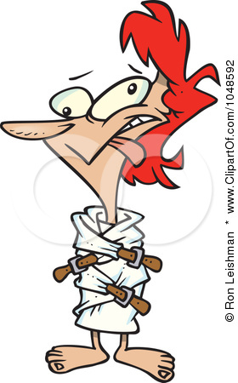

6
5

7
4

5
4

9

2

Breathe in….
Breathe out….
WHAT IS THE ONLY THING THAT IS DIFFERENT ABOUT TRAPEZOIDS?

3
2
4

4
3
6

1

10

5

2
4
7

